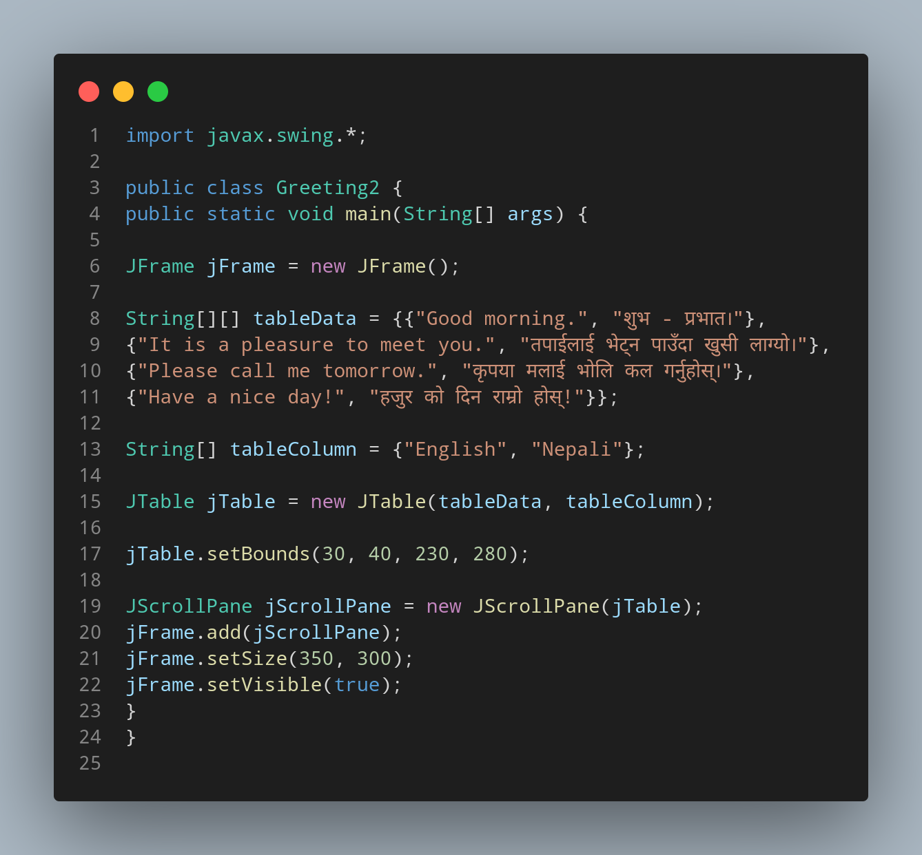

#Doc

First we import our javax.swing.

File name Greeting2 is created so we create a class name Greeting2, inside the class we created a main function.We instantiate jFrame class then create a String arrey named tableData , each value inside curly bracket store data in row seperated by comma(,). Three more data were added same as above. Now for the topic or heading row , we create a String Array having 2 data , each representing a language column.
Now we Instantiate our JTable with our tabulor datas( tableData ,tableColumn ) in order to represent data in tabulor form.

The all the bellow jTable function allows us to set the table boundries and size.
And with the help of our instantiated jFrame we can further edit our table format.

